Research Report on Broken Object Property Level Authorization (BOPLA)

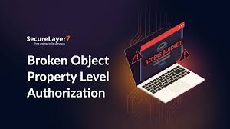

Introduction
Broken Object Property Level Authorization (BOPLA) refers to a security vulnerability where improper access controls on object properties allow unauthorized modifications or access to sensitive attributes. This issue often occurs in APIs and modern applications that utilize object-oriented data structures and exposes critical information or functionalities to attackers.

What is BOPLA?

BOPLA occurs when the application does not validate or restrict user access to specific object properties, allowing attackers to:

- Modify Object Properties: Attackers can change sensitive attributes, such as user roles or permissions.
- Access Restricted Data: Unauthorized access to sensitive fields or metadata.

Characteristics of BOPLA:

- Insufficient validation of object properties at both client and server levels.
- Reliance on client-side controls, leaving backend systems vulnerable.
- Commonly exploited in RESTful and GraphQL APIs.

Comparison of 2019 and 2023 OWASP API Top 10 with Respect to BOPLA
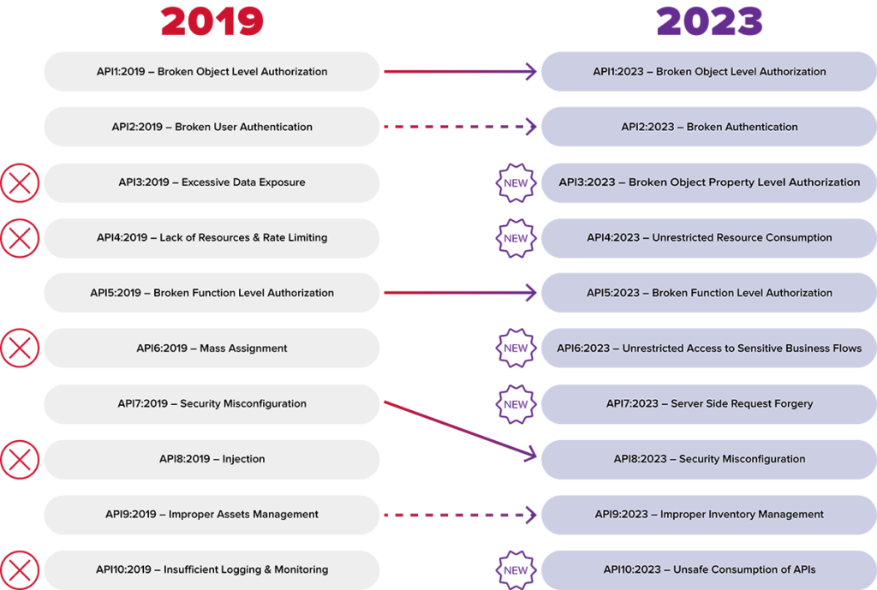

2019 OWASP API Top 10:
In 2019, BOPLA-related issues were not explicitly defined but fell under broader categories such as:
- API1:2019 - Broken Object Level Authorization: Focused on vulnerabilities at the object level but did not explicitly address property-level controls.
- API4:2019 - Lack of Resources & Rate Limiting: Indirectly related to excessive exposure by overlooking resource-level validation.

2023 OWASP API Top 10:
In the 2023 update, BOPLA gained clearer recognition due to the growing complexity of APIs:
- API3:2023 - Broken Object Property Level Authorization: Specifically addresses issues related to inadequate property-level authorization.
- API6:2023 - Mass Assignment: Highlights how automatic mapping of input data to object properties leads to exploitation.
- API2:2023 - Excessive Data Exposure: Emphasizes the risks of exposing unnecessary fields in API responses.
The explicit addition of BOPLA in the 2023 list underscores its rising prominence and the need for specialized mitigation strategies.

Excessive Data Exposure and Mass Assignment
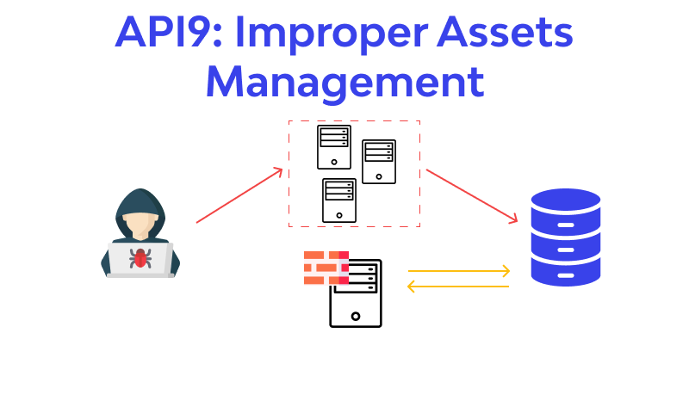

Excessive Data Exposure:
Occurs when APIs return more data than necessary to fulfill a request, inadvertently exposing sensitive information.

Example:
An API response for user details might include fields such as:
{
"id": 123,
"name": "John Doe",
"email": "johndoe@example.com",
"password": "hashed_password",
"role": "admin"
}
If the "password" or "role" fields are exposed, attackers could exploit this information for privilege escalation or account compromise.

Case Study:
- Incident: In a large e-commerce platform, excessive data exposure revealed sensitive user attributes, leading to targeted phishing campaigns.
- Impact: Compromised user accounts and financial losses.

Mass Assignment:
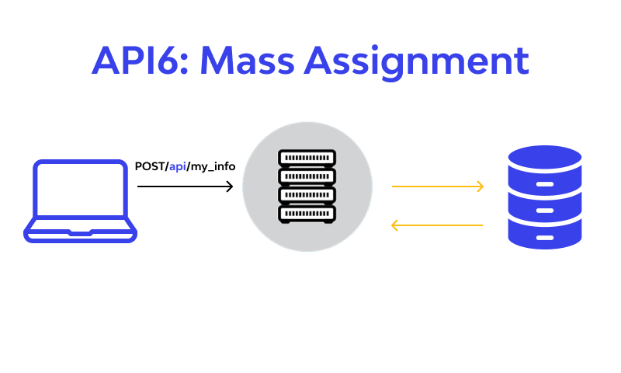

Occurs when APIs automatically bind client-supplied input to object properties without proper validation, allowing attackers to modify sensitive attributes.

Example:
An API endpoint for updating user profiles might process input like this:
{
"name": "John Doe",
"role": "admin"
}
If the "role" field is not properly validated, an attacker could escalate privileges by assigning themselves admin rights.

Case Study:
- Incident: A fintech application allowed attackers to exploit mass assignment vulnerabilities to modify account balance fields.
- Impact: Financial fraud and significant reputational damage.

Impact of BOPLA
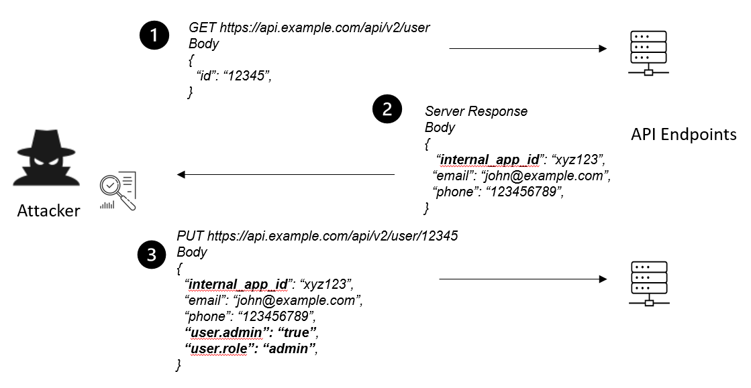

Technical Impacts:
- Unauthorized Data Access: Exposure of sensitive information like passwords, financial details, or PII (Personally Identifiable Information).
- Privilege Escalation: Attackers can modify roles or permissions, gaining unauthorized access to restricted functionalities.
- System Manipulation: Alteration of backend configurations or metadata, leading to operational disruptions.

Business Impacts:
- Data Breaches: Significant financial and reputational damage due to exposed sensitive data.
- Regulatory Penalties: Non-compliance with data protection regulations like GDPR, CCPA, or HIPAA.
- User Trust Erosion: Loss of customer confidence in the platform’s security.

Mitigation Strategies
- Server-Side Validation: Always enforce property-level authorization checks on the server.
- Whitelisting Properties: Restrict API responses and inputs to essential fields only.
- Input Sanitization: Validate and sanitize all client-provided data to prevent unauthorized modifications.
- Penetration Testing: Conduct regular API security tests to identify and address BOPLA vulnerabilities.
- Use of Security Tools: Employ API security gateways and automated testing tools to detect excessive data exposure and mass assignment risks.

Conclusion
Broken Object Property Level Authorization (BOPLA) poses a critical threat to modern applications, particularly those leveraging APIs. With its inclusion in the OWASP API Top 10 for 2023, BOPLA highlights the importance of robust property-level access controls and continuous security testing. By adopting best practices and leveraging modern security tools, organizations can mitigate these risks, safeguarding their applications and users from potential exploitation.

References
- OWASP API Security Top 10 (2023). OWASP.
- REST API Security Guide (2025). API Academy.
- Postman Security Testing Guide (2025). Postman.
- Burp Suite Documentation (2025). PortSwigger.
- Symantec Threat Report (2024). Symantec.
- GDPR Compliance Guidelines (2025). European Commission.

